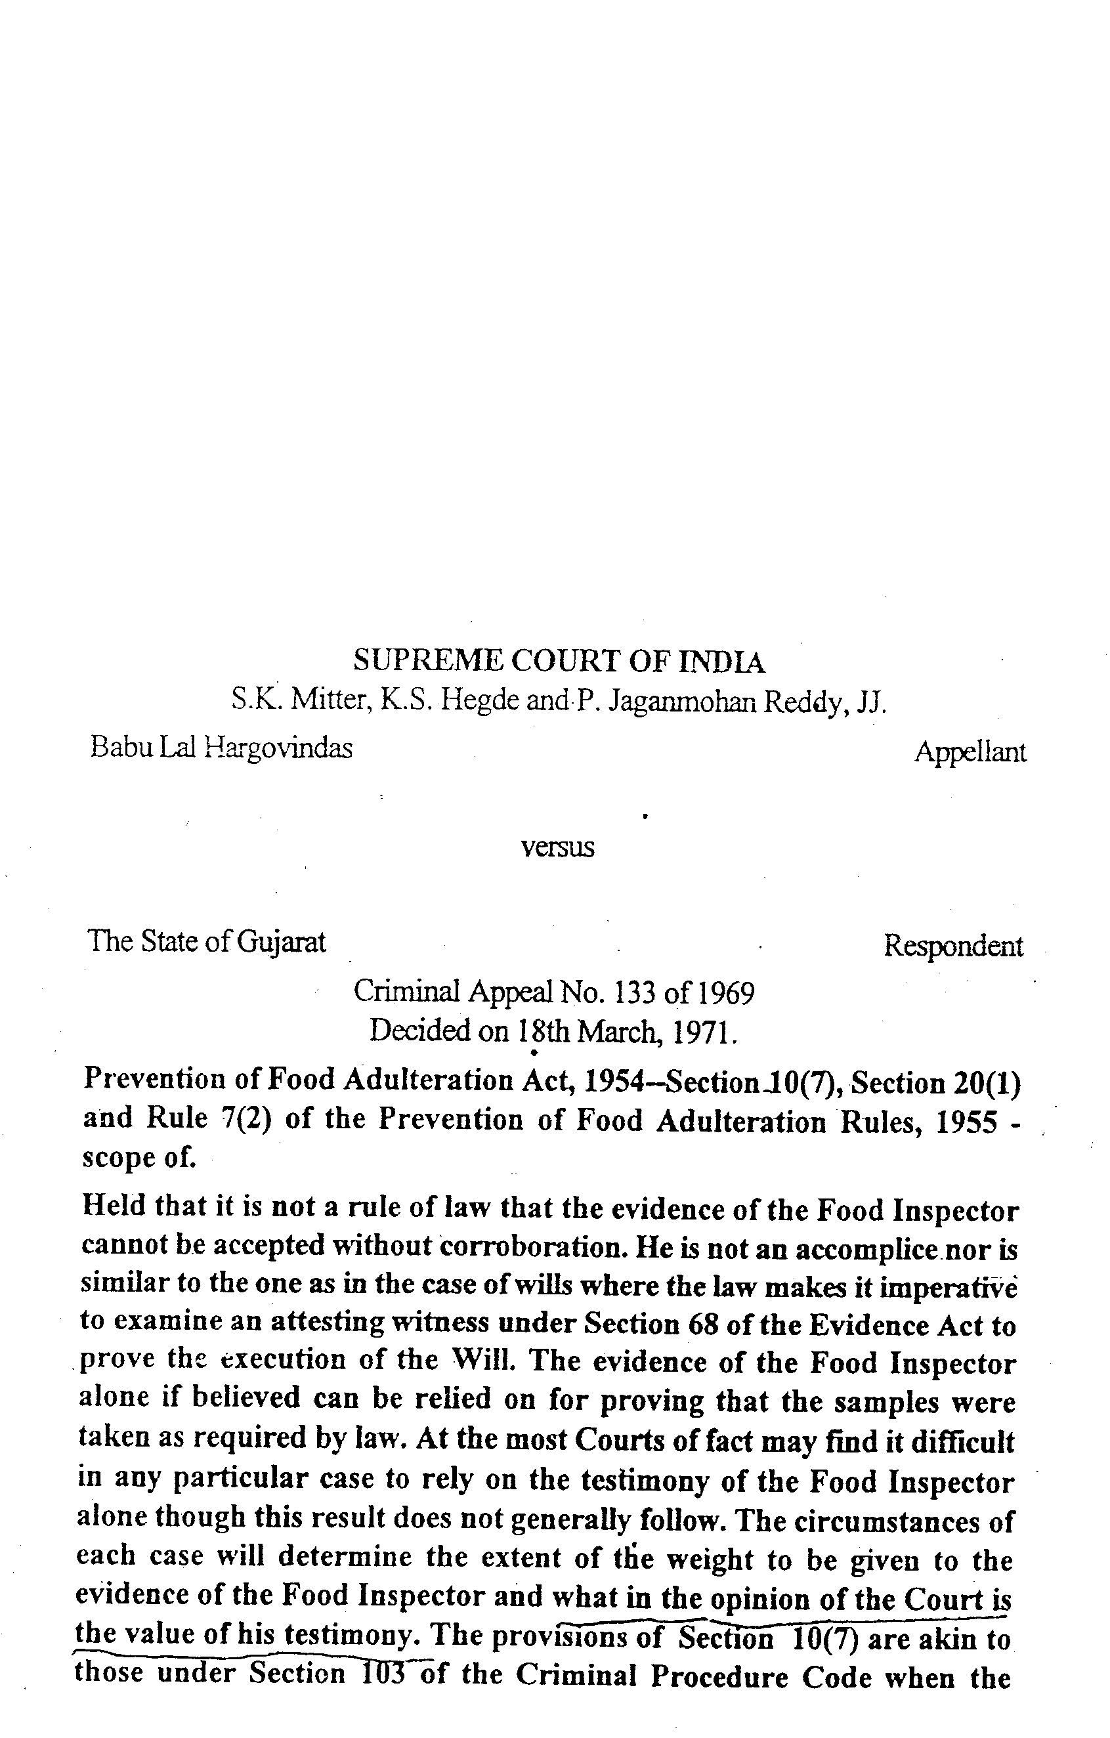
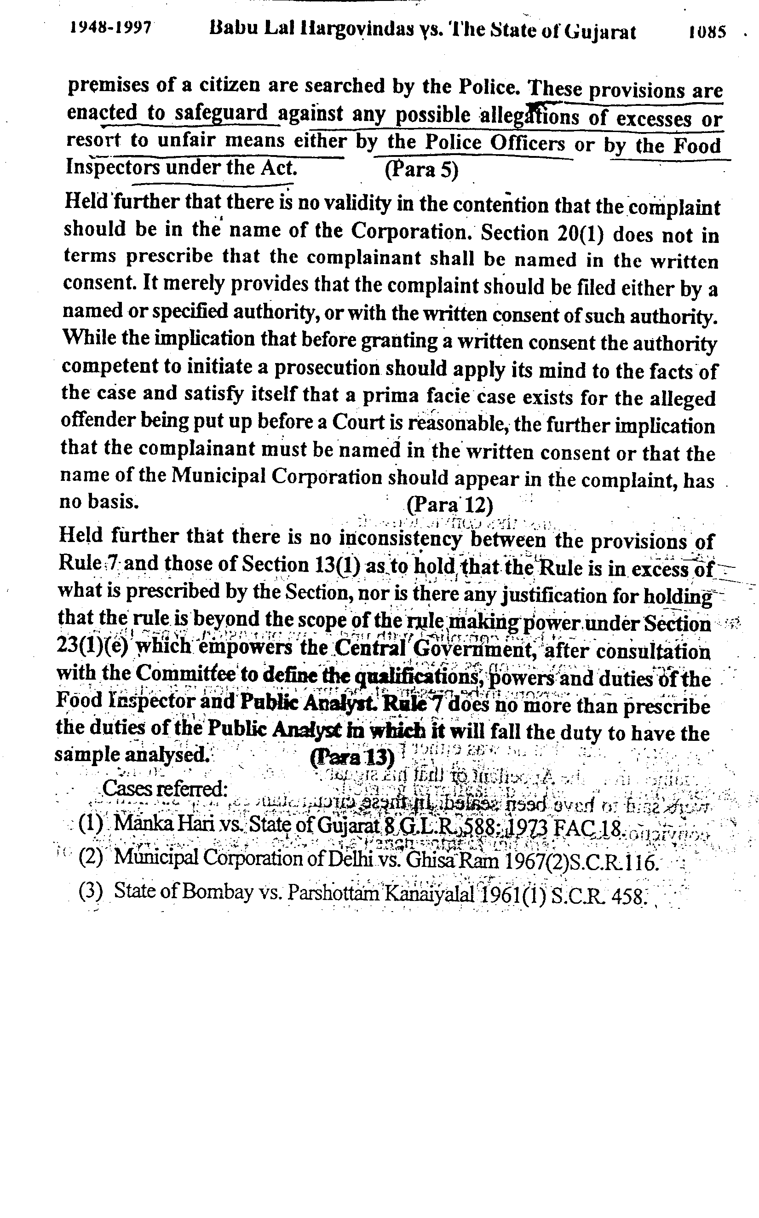

Note:-
Testimony of Food Inspector held and Appeal accordingly Dismissed.
Full ruling can be obtained on request at upgovfi@sify.com

